Pareto optimal
PD is useful for retail price war between two shops or between 2 retail chains. What they can do is Either set price as high(H) or as low(L). so, now let’s model it as game between two retail shops.
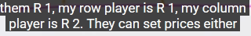ways.
1st way (HH) both set price as high, At (LL) both set low price. Same in (HL) and (LH).
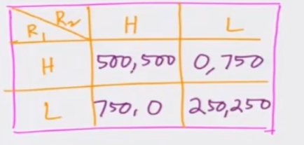

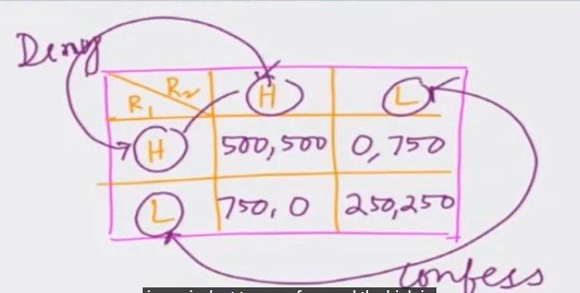
Now you can interpret it as prisioners Delimma as done above. In this case LL is the best case that satisfy nash equilibrium.
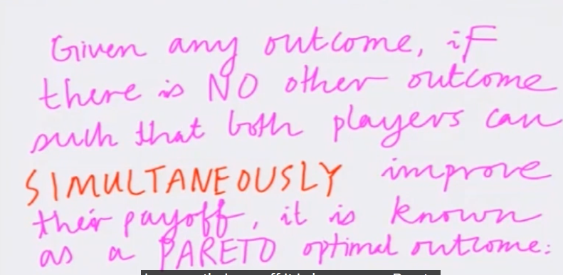

SO (H,H) IS PARETO OPTIMAL OUTCOME.
Dominant Strategies
A Dominant Strategy is an action that is always the best response, no matter what the other players choose
.
• Example: Cold War: Two countries choose to invest in Health (H) or Defense (D)
.
• Payoffs: (H,H) = 100 each; (D,D) = 10 each; if one picks Defense and the other Health, the Defense country gets 150 (strategic advantage) and the other gets -100
.
• Result: Defense is a dominant strategy because a country is better off choosing Defense whether its neighbor chooses Health or Defense
.
• Dominant Strategy Equilibrium: When both players have a dominant strategy, the combination of those strategies forms a special, very strong Nash Equilibrium

Practical Intuition
(Loud Parties & Concerts)

The sources provide easy-to-understand examples of dominant strategy equilibria in daily life:
• Loud Parties: Even if everyone prefers a quiet conversation, your best response is to shout to be heard. Since shouting is everyone's dominant strategy, the room becomes very loud
.
• Concerts: At an open-air concert, even if there are chairs, if the person in front of you stands up, you must stand up to see
. Eventually, everyone is standing—even though everyone might have preferred to sit—because standing is the dominant strategy

